PRESS RELEASE
COMMUNICATIONS AND MEDIA TEAM OF THE 43RD ASEAN SUMMIT 2023
No. 102/SP/TKM-ASEAN2023/ENG/9/2023

Indonesia’s Cultural Wealth Mesmerizes the ASEAN First Ladies
Jakarta, 6 September 2023 – The Spouse Program of the 43rd ASEAN Summit at Taman Mini Indonesia Indah (TMII) was a successful and festive event. The reception of the ASEAN First Ladies at the event showcased a variety of distinctive arts, culinary, customs, and culture of the Indonesian archipelago.
The event began at 09:00 AM local time when the Indonesian First Lady Iriana Joko Widodo appeared gracefully, dressed in a purple batik kebaya encim of Betawi (traditional Jakarta attire) with floral patterns complete with a shawl in the same color, to welcome the guests.
“The event was lively, smooth, and successful from the start at 09:00 AM local time until it concluded at 12:00 PM local time,” said Arie Prasetyo, the Director of Operations at TMII, when contacted by the Communications and Media Team on Wednesday (6 September 2023).
The first location visited by the entourage of the First Ladies was the art gallery. For approximately 20 minutes, they were invited to watch children with disabilities create various artworks, including painting, sculpting, pottery, and comics.
The group then continued their activities by watching a traditional Betawi dance performance performed nicely and gracefully by female dancers.
Afterward, the guests were led to the Panggung Budaya (Cultural Stage) which is located right next to the Archipelago Lake. Once again, they were entertained with various outdoor entertainment, allowing them to fully appreciate the beauty of the miniature Indonesian islands in the middle of the lake with clear visibility.
The group also enjoyed a parachute performance, dance, and musical instrument performance from artists aged between 17 and 30. A total of 1,500-2,000 performers showcased their talents in front of the ASEAN First Ladies.
Next, they headed to the luncheon venue at Sasono Utomo. This facility is a hall frequently used by companies and individuals to host luncheons. The hall has distinctive and visually appealing architecture.
The First Ladies traveled from Panggung Budaya to Sasono Utomo by an electric car, passing through the pavilions of East Kalimantan, South Kalimantan, Aceh, North Sumatra, South Sumatra, and Bengkulu. They were treated to various fascinating attractions at each pavilion.
For example, the delegation witnessed a performance of the indigenous people’s daily activities at the East Kalimantan pavilion. These activities include drying cloth while wearing the traditional attire of East Kalimantan. Meanwhile, a group of young men and women performed a traditional South Sumatra dance at the region’s pavilion.
When passing through the North Sumatra pavilion, children playing traditional musical instruments of North Sumatra greeted the group of First Ladies.
The group stopped at each pavilion for a while to observe each displayed culture. “There was a delay as the ASEAN First Ladies passed through the pavilions,” said Arie.
At the end of the visit, Arie said that the First Ladies made a stop to purchase local products displayed by around 10 micro, small, and medium-sized enterprises (MSMEs).
“The First Ladies went on a shopping spree for MSME products at TMII. They were so amazed that pottery, clothing, paintings, and sculptures were all sold out,” he said. (WW)
***
For more information, please contact:
Director General of Public Information and Communications of the Ministry of Communications and Informatics – Usman Kansong (0816785320).
Get more information at http://asean2023.id, https://infopublik.id/kategori/asean-2023, and https://indonesia.go.id/kategori/ragam-asean-2023

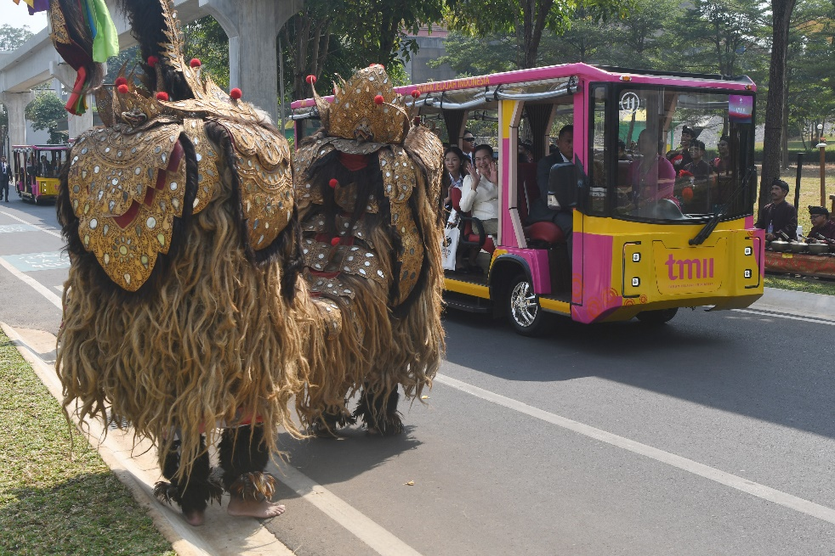
Mrs. Vandara Siphandone (left) along with the First Ladies of ASEAN and Asia Pacific leaders, as well as spouses of global financial institution leaders, ride an electric vehicle called Angling while observing various Indonesian cultural attractions during the Spouse Program of the 43rd ASEAN Summit 2023 at Taman Mini Indonesia Indah, Jakarta, on Wednesday (6 September 2023). Media Center ASEAN Summit 2023/Dhoni Setiawan/aww
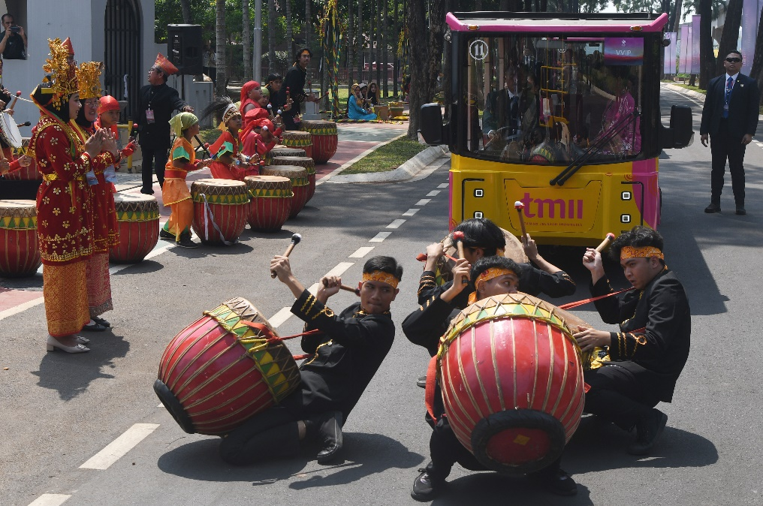
Mrs. Iriana Joko Widodo, along with the First Ladies of ASEAN and Asia Pacific leaders, as well as spouses of global financial institution leaders, ride an electric vehicle called Angling while observing various Indonesian cultural attractions during the Spouse Program of the 43rd ASEAN Summit 2023 at Taman Mini Indonesia Indah, Jakarta, on Wednesday (6 September 2023). Media Center ASEAN Summit 2023/Dhoni Setiawan/aww
Mrs. Kim Keon Hee (left) inspects various handcrafted bags produced by Indonesian MSMEs during the Spouse Program of the 43rd ASEAN Summit 2023 at Taman Mini Indonesia Indah, Jakarta, on Wednesday (6 September 2023). Media Center ASEAN Summit 2023/Dhoni Setiawan/aww.

